**Packet Tracer Network Design Justification & Report**

**A full copy of the packet tracer design can be found attacked to this report. This report we cover the overall network design and will justify the layout.**

## Managers and Support Team:

Sports4u requested that we implement a separate subnet for the managers and technical support team’s computers and printers. As such you can see in the below image that I have separated their system off into its own subnet on the overall network. All the computers and network printers are connected through central switch to the main the router to allow fast interconnectivity between all machines.

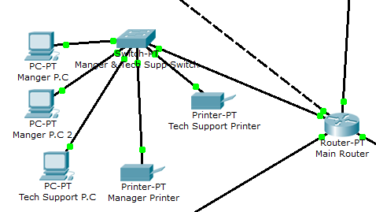

## Sales and Reception:

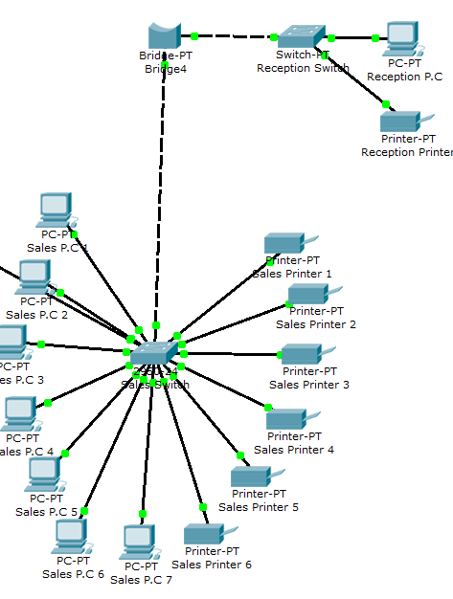A separate subnet was set out for the sales and reception team as requested sports4u. Again all computers and printers for the sales team are connected via a central switch to allow fast network communication to both them and the other subnets on the overall network. The Reception however is further split off into its own area using a network bridge. This is to help cut with any bandwidth issues that may arise as there are a lot of devices on this single subnet. The Reception has a dedicated switch to allow fast communication between their printer and computer, this section is also separated by a bridge to ensure that any network data being sent from the reception P.C to the printer only has to travel from the P.C to the reception switch and not all the way to the sales switch unless the reception needs to access one of the sales teams printers or the file/web/mail servers at which point the data is still sent over the bridge through the whole network.

## Servers

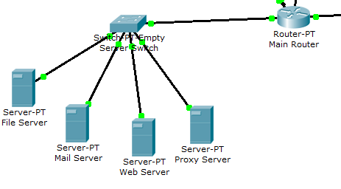Sports4u have requested the following services to be part of their network; Web, Mail and File. I have also included a proxy server as part of the overall network setup for added security upon this network. All these servers as you can see below are part of their own subnet with their own router. While this will increase the cost of the overall network setup it is a must have to have these services on their own subnet, this is because the servers are going to be in high demand by the whole company and thus they need a fast an easy way to access them. By setting these servers onto their own subnet I am able to ensure that the connection between them is faster than that of the standard P.C’s and printers, they have a 1Gbit connection to the servers and thus a lot more bandwidth. This will cut down immensely on any bottlenecks that may appear when multiple people try to access something such as the web server all at once. Also by having them on their own subnet you are better able to secure those servers which is a must have when the file server will be storing sensitive data.

## Internet Access and Wireless Access:

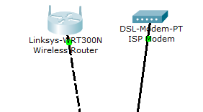To allow for internet access I have connected the ISP modem directly to the main router of the overall network. This will allow for all devices on the network to connect directly to the internet through the router whenever they like with ease. All devices are connected to the central router with their own IP’s and thus are connected to the internet through the router and modem. The modem has its own IP for configuration purposes such as port forwarding/blocking and security setups. The wireless access point is separated and connected directly to the main router to allow for easy wireless access to any part of the network, as-long as you have the correct privileges and access rights to access the area you are connecting to. I have set it up this way to make sure there is no added bandwidth issues to a single subnet of the network just because someone wishes to use wireless.

Justification Of Components

Here I will cover every component that the network solution I have designed requires and cover the overall idea of what each component will be doing.

## ISP Modem

The ISP modem is a must have on any network that requires an external access to the internet or World Wide Web. This device is needed because it allows communication between your network and the outside internet through your company’s internet service provider.

## Wireless Access Point

This wireless access point is needed to allow for the Field Sales Staff to gain wireless access to the overall network and internet services. This device will allow your Field Sales Staff to access the network wirelessly using any WIFI enabled device providing the have the access rights to do so. This device will also make it possible for sports4u to setup an internal wireless internet access point for the employees of the company to use on their meal breaks and at other times if you so require. This device will also allow any member of staff such as a manager to access any area of the network easily from a WIFI enabled devices if he/she so wishes.

## Main Router

The main router is what connects everything together, it is needed because without it you are unable to connect and setup multiple subnets for the sports4u company. A subnet is an important thing as it allows you to take full advantage of all the bandwidth available on your network, you could in theory have all the devices connected to a central switch and then to the ISP modem however this would cause a massive amount of congestion on the network and it would be near impossible to send out and receive information between the computers and other devices on the network. Having a router allows you to have subnets which allow you in turn to have separate tiny networks inside an overall large network. For example without the router and subnets, any information sent from a sales rep teams computer would have to travel all the way to the central switch and then all the way back to sales rep printer. However when you have a subnet the information only has to travel as far as the switch for that one subnetwork and then to its destination. This is both incredibly fast and efficient.

## Manager and Tech Support Switch

The manager and tech support switch is what connect the managers computers and printers to the tech supports computer and printer in its own little subnet as requested by sports4u. This allows you to have very fast communication between the devices on that area of the subnet while still allowing you to access any other area of the network if you need to. This switch is needed so you can have the computers and printers in this subnet connected together in an efficient way.

## Sales Team Switch

The sales team switch is a lot larger than any other switch on the network with a total of 20 1GBIT ports on it. This is to ensure that there are enough ports to allow each and every computer and printer in the sales team to connect to each other in a way that is fast and efficient. This switch is also needed so we are able to connect the sales team and receptionist’s computers to the overall network (router).

## Reception Bridge

The reception bridge was implemented at the request of sports4u. It allows you to have a separate area of the overall sales and reception subnet while not needing to setup a different IP subnet for the reception. What this does in essence is split off the reception machines into their own little area, for example; any data sent from the reception P.C to the reception printer will only have to travel as for as the reception switch to get to its destination, it will not have to travel past the bridge. However if any data needs to be sent to another area of the network or if a server needs to be accessed from the reception, they can do so as the bridge also allows you to connect to the rest of the network through it.

## Reception Switch

The reception switch is needed because it connects the reception P.C to the reception printer. This is a lot more efficient than having the printer connected directly to the reception P.C as it allows for an expanded use case of the printer. For example; in this setup if the reception needed something from the manager and it needed to be printed out, the reception could simply call through to the manager and have them print the requested document out on the reception printer. This increases the overall efficiency of the company.

## Server Switch

The servers as mentioned above are all on their own subnet, this is to allow for a faster than standard speed between the servers and the other areas of the network. This is needed because the servers are going to be machines that are accessed from many of the devices on the network and sometimes all at the same time, as such it needs a faster connection to handle the increase in bandwidth, this switch is required because it allows you to simply have all the server connected on their own super-fast 1Gbit subnet and thus cuts down on price due to having all the super-fast servers in one specified area of the network.

## Mail Server

The mail server allows you to send and receive internal company E-Mails throughout the company and also allows you to setup a secure E-Mail that is fully controlled by sports4u which can be used to communicate with potential customers and clients of sports4u. This mail server will be a standalone machine to allow for better security implementation as having different servers split off onto their own machines allows you to better define what access rights people have, further more it allows you to setup proxy rights because it will have its own IP, this allows you to add further security to the areas of your network.

## Web Server

The web server was implemented as requested by sports4u, this device will allow sports4u to setup and run their own website for the company. By having it as a standalone computer you are able to give it its own dedicated static IP which (as is the case with the mail server) allows you take full advantage of the proxy server protection implemented on this network.

## File Server

The file server is most likely one of the most important servers on this whole network as it’s going to be the device that stores all company data such as client info, order info and other sensitive information. As such having a standalone server for this allows you again to take full advantage of the proxy server as-well as allows you to have an incredibly fast dedicated connection directly into the server from the switch. This is a must have because the file server is going to be the device that gets hit the hardest in regards to bandwidth, this is mostly because of the amount of people that are going to be using it on a daily basis. Having a standalone server for the file server allows you to take full advantage of the Cat 6 10Gbit Ethernet cable that connects it to the switch and router on the network.

## Proxy Server

The proxy server was not requested by sports4u however is a must have for any company that is going to be holding sensitive client and company information on its network. The proxy server adds a huge layer of control and protection upon your network as it allows to monitor and restrict just about anything you would ever want to monitor and restrict. Having this as a standalone machine is also needed because this device is going to be handling all the internal and external data flow for the whole company and thus needs a dedicated line to handle that amount of bandwidth. This device will increase the overall security of the network and allow you to keep check on everything you may want easily such as check which areas of the network are getting hit the hardest in terms of bandwidth as-well as keep check on any client that may be using the internet services to do non work related things during work hours.

## Cat 5 Ethernet Cable

This is a must have as it’s the cable that is going to be linking every machine and every component on the network with exception to the ISP modem and Server subnet. Cat 5 cable has a rated usage speed of around 1Gbit and is incredibly inexpensive to implement, this makes it the perfect cable both in terms of cost and in terms of speed for the sports4u network. This is also a universally used cable meaning it is simply plug and play with any device on the network and will continue to be so long into the future, this help with expandability in the future.

## Cat 6 Ethernet Cable (10Gbit model)

The Cat 6 Ethernet Cable is needed mainly for the servers and access to the internet through the ISP modem. This cable is needed because of its added speed capabilities. While cat 5 would probably be fast enough to run all the servers upon and for the ISP modem, it would be cutting it close in high bandwidth times of day. As such it doesn’t make sense to implement as if there is ever an increase in the amount of people connect to the network such as via WIFI devices or if there is ever a need to increase the amount of devices on the network, cat 5 would be unable to keep up very quickly. In comes Cat 6 with its rated 10Gbit connection speeds, while the overall network will be using 1Gbit, the servers will all be using 10Gbit connections to the overall network and ISP modem. This allows for a massive amount of devices to all connect and use the servers at the same time with ease and will allow for any amount of people to access them wirelessly at the same time too if it’s needed. It also allows for expandability in the future and by only using it in the high bandwidth areas, you are also cutting down on costs now and further possible costs in the future.